# Code test – Payroll Calculator

## Background

Your job is to build a payroll calculator. A user should be able to fill in information about their profession and employment in a form and then see what their salary will be after tax.

At the bottom of this document, you will see an example of what such a form could look like. Don’t copy the look straight off but build your own solution with what you consider to be a modern and responsive design. The example only illustrates what the form should contain.

## Form

In the form you should be able to fill in the following information:

* Number of years of experience
* Occupation (3 specific choices)
  + Programmer
  + Teacher
  + Cashier
* City (2 specific choices)
  + Stockholm
  + Gothenburg
* Income year (2 specific choices)
  + 2020
  + 2019

## Conditions for calculation

**Basic salaries before tax:**

Developer: SEK 30,000

Teacher: SEK 27,000

Cashier: SEK 25 000

**Number of years of experience:**

0-3 years of experience does not give a pay rise

4-7 years of experience gives a salary increase of **20%** in addition to basic salary

8-10 years of experience gives a salary increase of **40%** in addition to basic salary

11+ years of experience gives a salary increase of **60%** in addition to basic salary

**Basic tax rate** **/ Location**

The basic tax rate is based on city and income year and is applied to salary between SEK 0 - 36,000:

* Stockholm
  + Inkomstår 2019: 30%
  + Inkomstår 2020: 29%
* Gothenburg
  + Inkomstår 2019: 25%
  + Inkomstår 2020: 22%

**Extra high-income tax:**

If you earn between SEK 36,000 - SEK 45,000, you also pay 50% tax on all salary between SEK 36,000 - 45,000, in addition to the basic tax on the amount of SEK 0 - SEK 36,000

If you earn more than SEK 45,000, you also pay 50% tax on all salary between SEK 36,000 - 45,000 and 70% tax on anything over SEK 45,000, in addition to the basic tax rate of sek 0 - 36,000

## Demand

1. You decide tools yourself, as long as it is Javascript-based (Typescript is also OK) and works to open in a browser. E.g. Vanilla JS, Angular, React, Vue. It's not OK to use something that's not based on JavaScript.
2. If you want to install external npm packages, it is perfectly OK as long as you can justify why it is worth the extra maintenance.
3. The interface must be fully responsive
4. When the test is complete, post it on GitHub and send us the URL to your repo with clear installation instructions in a README.md file in repot.
5. Tackle the task as if it were an app you would have delivered to a real customer.
6. We have no time limits for this test. Spend as much time as you want but don't compromise on quality.

## The following we will draw attention to:

* Design & Creativity
* Readable code
* Scalability
* Separation of concerns
* Testability

## Examples of what the form might look like:

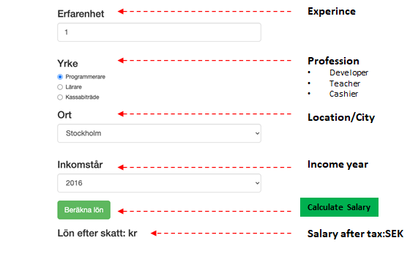

## Good luck!

## We are excited about how you will solve it!